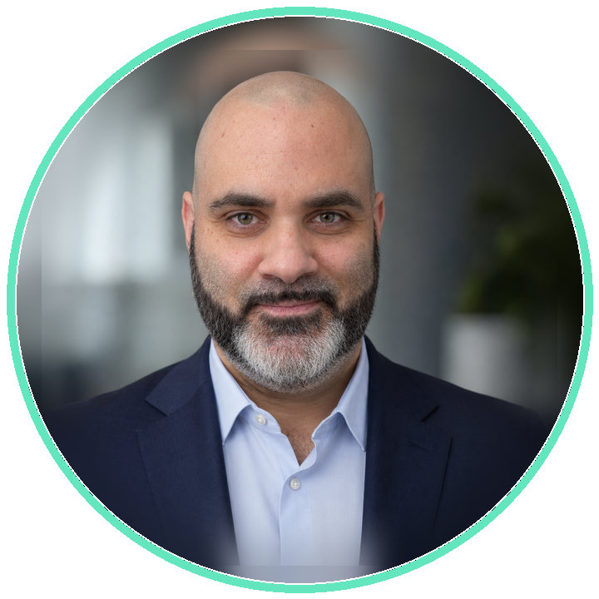  CONTATTI PROFESSIONALI  Email  info@marfedlab.it  Sito  www.marfedlab.it  LinkedIn  Marco Federici  WhatsApp Business  Messaggia su WhatsApp  PROFILO  Circa 20 anni di esperienza in infrastrutture enterprise, endpoint management, VDI, cloud, cybersecurity, backup e disaster recovery. Oggi unisco competenze hands-on, coordinamento operativo e formazione tecnica strutturata.  COMPETENZE CHIAVE  • IT coordination e delivery  • Assessment e remediation  • Microsoft Intune  • Omnissa Workspace ONE UEM  • Omnissa Horizon / VDI  • Microsoft 365 e Google Workspace  • Windows Server e Active Directory  • VMware vSphere e vSAN  • Backup, DR e cyber protection  • EDR, XDR, SIEM e hardening  • NIS2, ISO 27001, PCI-DSS  • Docenza tecnica e knowledge transfer  CERTIFICAZIONI  • Microsoft 365 Certified: Endpoint Administrator Associate  • Omnissa Certified Administrator - Horizon  • Acronis Cloud Tech Fundamentals  • Acronis Cloud Tech Associate  • Acronis RMM Professional  • Acronis Cyber Infrastructure  • Acronis Advanced Data Loss Prevention  • Acronis EDR + Advanced Security  • Acronis Advanced Disaster Recovery  • Acronis Disaster Recovery Professional  LINGUE  Italiano - Madrelingua  Inglese - Comprensione C1; produzione/interazione B1  PRIVACY  Privacy by design. Questa versione non contiene dati sensibili. Sono visibili soltanto i riferimenti professionali | Marco Federici  IT Coordinator | Senior Solution Engineer | Technical Trainer  IT · Professional Services • Infrastructure • Modern Workplace • Cybersecurity  PROFILO PROFESSIONALE  Senior Solution Engineer e IT Coordinator con responsabilità di coordinamento operativo e gestionale dei Professional Services. Guido pianificazione, priorità, qualità del delivery, gestione delle escalation e collaborazione tra team tecnici, clienti, vendor e stakeholder interni. Mantengo un coinvolgimento tecnico diretto nei progetti, traducendo requisiti infrastrutturali, operativi e di sicurezza in soluzioni sostenibili, documentate e governabili.  ESPERIENZA PROFESSIONALE  IT Coordinator & Senior Solution Engineer  C&C S.p.A. | Roma | 11/2024 - Presente  • Coordinamento operativo e gestionale delle attività tecniche e progettuali dei Professional Services, con presidio di priorità, risorse e qualità del delivery.  • Pianificazione delle priorità, gestione escalation, supporto al cliente e presidio della qualità del delivery.  • Progettazione e implementazione di soluzioni di modern workplace, endpoint management, VDI, cybersecurity, backup e disaster recovery.  • Assessment, hardening e remediation con attenzione a governance IT, NIS2, ISO 27001, PCI-DSS e continuità operativa.  • Docenze tecniche, demo operative, laboratori pratici, materiale didattico e knowledge transfer.  Senior System Administrator / Domain Administrator  Assist Digital | Roma | 09/2021 - 11/2024  • Amministrazione di ambienti Windows Server, Active Directory, servizi ibridi, Google Workspace e infrastrutture virtualizzate.  • Implementazione e gestione di ambienti VDI VMware Horizon, UAG, desktop pool, Gold Image e VMware DEM.  • Gestione Workspace ONE UEM per policy, profili, applicazioni e configurazioni endpoint.  • Supporto a compliance PCI-DSS, hardening, analisi log e security operation con CrowdStrike.  • ADFS, deployment Microsoft MDT/PXE e backup tramite Veeam Backup & Replication.  System Engineer  NPO Sistemi | Roma | 11/2020 - 09/2021  • Gestione di ambienti Microsoft 365, Exchange Online e scenari hybrid cloud.  • Deployment automatizzato tramite Microsoft MDT e standardizzazione delle immagini client.  • Supporto sistemistico e troubleshooting su infrastrutture ibride Microsoft.  • Analisi eventi di sicurezza tramite piattaforme ReaQta / IBM.  System Engineer  Olisistem Start | Roma | 03/2016 - 10/2020  • Gestione di ambienti VDI VMware Horizon e continuità dell'esperienza utente.  • Amministrazione profili con VMware Persona Management.  • Distribuzione software e gestione endpoint tramite Microsoft SCCM.  • Supporto infrastrutturale client/server e sistemi di videoconferenza Polycom.  Sistemista  E-Care S.p.A. | Roma | 02/2010 - 02/2016  • Amministrazione Windows Server, Active Directory, file server, print server e servizi applicativi.  • Gestione Microsoft Exchange Server e sicurezza endpoint tramite Sophos.  • Distribuzione software, monitoraggio, manutenzione e risoluzione incidenti.  IT Support / Tecnico Sistemi Informatici  E-Care S.p.A. | Roma | 10/2007 - 02/2010  • Installazione e manutenzione di desktop, notebook, periferiche e software aziendale.  • Supporto VoIP su Avaya, apparati Cisco Catalyst e print server Windows.  • Troubleshooting hardware, software e networking.  IT Support Specialist  Infosys S.r.l. | Roma | 08/2005 - 02/2007  • Assistenza tecnica su PC, notebook, stampanti e periferiche.  • Configurazione di apparati di rete e postazioni per privati e piccole aziende.  • Diagnosi e manutenzione hardware/software.  DOCENZA E FORMAZIONE TECNICA  • Progettazione ed erogazione di percorsi formativi strutturati per clienti, team IT e risorse interne.  • Sessioni su Microsoft Intune, Omnissa Workspace ONE UEM, Omnissa Horizon e Acronis Cyber Protect Cloud.  • Preparazione di contenuti tecnici, demo operative, laboratori pratici e materiale di supporto.  • Formazione su enrollment, policy, compliance, sicurezza endpoint, backup, disaster recovery, VDI e troubleshooting.  • Supporto alla crescita dei team e alla standardizzazione delle procedure operative.  AREE TECNOLOGICHE  Infrastructure & Cloud  Windows Server, Active Directory, VMware vSphere, vSAN, hybrid cloud, Google Cloud.  Modern Workplace & UEM  Microsoft Intune, Omnissa Workspace ONE UEM, Microsoft 365, Google Workspace.  VDI & Digital Workspace  Omnissa Horizon, Citrix, UAG, DEM, Gold Image, FSLogix, sicurezza degli accessi.  Cybersecurity & Compliance  EDR/XDR, SIEM, hardening, NIS2, ISO 27001, PCI-DSS, governance e remediation.  Backup & Resilience  Acronis Cyber Protect Cloud, Veeam, Commvault, business continuity e disaster recovery.  ISTRUZIONE  Diploma di Perito Informatico  ITIS E. Fermi, Frascati | 2004  REFERENZE PROFESSIONALI  Giuseppe Zappalà  Amministratore Delegato - Q8 Petroleum Italia  Precisione, puntualità, affidabilità, collaborazione e orientamento alla soluzione.  Vincenzo Maniaci  IT Technology Group Director - Q8 Petroleum International  Competenza tecnica, condivisione della conoscenza e lucidità nelle situazioni critiche.

PROFESSIONAL CONTACTS  Email  info@marfedlab.it  Website  www.marfedlab.it  LinkedIn  Marco Federici  WhatsApp Business  Message on WhatsApp  PROFILE  Nearly 20 years of experience across enterprise infrastructure, endpoint management, VDI, cloud, cybersecurity, backup and disaster recovery. Today I combine hands-on expertise, operational coordination and structured technical training.  CORE EXPERTISE  • IT coordination and delivery  • Assessment and remediation  • Microsoft Intune  • Omnissa Workspace ONE UEM  • Omnissa Horizon / VDI  • Microsoft 365 and Google Workspace  • Windows Server and Active Directory  • VMware vSphere and vSAN  • Backup, DR and cyber protection  • EDR, XDR, SIEM and hardening  • NIS2, ISO 27001, PCI-DSS  • Technical training and knowledge transfer  CERTIFICATIONS  • Microsoft 365 Certified: Endpoint Administrator Associate  • Omnissa Certified Administrator - Horizon  • Acronis Cloud Tech Fundamentals  • Acronis Cloud Tech Associate  • Acronis RMM Professional  • Acronis Cyber Infrastructure  • Acronis Advanced Data Loss Prevention  • Acronis EDR + Advanced Security  • Acronis Advanced Disaster Recovery  • Acronis Disaster Recovery Professional  LANGUAGES  Italian - Native speaker  English - C1 comprehension; B1 written and spoken interaction  PRIVACY  Privacy by design. This version contains no sensitive personal data. Only professional contact details are included. | Marco Federici  IT Coordinator | Senior Solution Engineer | Technical Trainer  EN · Professional Services • Infrastructure • Modern Workplace • Cybersecurity  PROFESSIONAL PROFILE  Senior Solution Engineer and IT Coordinator responsible for the operational and managerial coordination of Professional Services. I lead planning, prioritisation, delivery quality, escalation management and collaboration across technical teams, customers, vendors and internal stakeholders. I remain directly involved in projects, translating infrastructure, operational and security requirements into sustainable, documented and governable solutions.  PROFESSIONAL EXPERIENCE  IT Coordinator & Senior Solution Engineer  C&C S.p.A. | Rome | 11/2024 - Present  • Operational and managerial coordination of Professional Services technical and project activities, overseeing priorities, resources and delivery quality.  • Priority planning, escalation management, customer support and oversight of delivery quality.  • Design and implementation of modern workplace, endpoint management, VDI, cybersecurity, backup and disaster-recovery solutions.  • Assessment, hardening and remediation with a focus on IT governance, NIS2, ISO 27001, PCI-DSS and business continuity.  • Technical training, operational demos, hands-on labs, learning materials and knowledge transfer.  Senior System Administrator / Domain Administrator  Assist Digital | Rome | 09/2021 - 11/2024  • Administration of Windows Server, Active Directory, hybrid services, Google Workspace and virtualised infrastructure.  • Implementation and operation of VMware Horizon VDI environments, UAG, desktop pools, gold images and VMware DEM.  • Workspace ONE UEM administration for policies, profiles, applications and endpoint configurations.  • Support for PCI-DSS compliance, hardening, log analysis and security operations with CrowdStrike.  • ADFS, Microsoft MDT/PXE deployment and backup with Veeam Backup & Replication.  System Engineer  NPO Sistemi | Rome | 11/2020 - 09/2021  • Management of Microsoft 365, Exchange Online and hybrid-cloud environments.  • Automated deployment with Microsoft MDT and standardisation of client images.  • Systems support and troubleshooting across hybrid Microsoft infrastructure.  • Security-event analysis using ReaQta / IBM platforms.  System Engineer  Olisistem Start | Rome | 03/2016 - 10/2020  • Operation of VMware Horizon VDI environments and continuity of the user experience.  • User-profile administration with VMware Persona Management.  • Software distribution and endpoint management with Microsoft SCCM.  • Client/server infrastructure support and Polycom videoconferencing systems.  Systems Administrator  E-Care S.p.A. | Rome | 02/2010 - 02/2016  • Administration of Windows Server, Active Directory, file servers, print servers and application services.  • Microsoft Exchange Server administration and endpoint security with Sophos.  • Software distribution, monitoring, maintenance and incident resolution.  IT Support / IT Systems Technician  E-Care S.p.A. | Rome | 10/2007 - 02/2010  • Installation and maintenance of desktops, notebooks, peripherals and business software.  • VoIP support on Avaya, Cisco Catalyst devices and Windows print servers.  • Hardware, software and network troubleshooting.  IT Support Specialist  Infosys S.r.l. | Rome | 08/2005 - 02/2007  • Technical support for PCs, notebooks, printers and peripherals.  • Configuration of network devices and workstations for individuals and small businesses.  • Hardware/software diagnostics and maintenance.  TECHNICAL TRAINING  • Design and delivery of structured training programmes for customers, IT teams and internal staff.  • Sessions covering Microsoft Intune, Omnissa Workspace ONE UEM, Omnissa Horizon and Acronis Cyber Protect Cloud.  • Preparation of technical content, operational demos, hands-on labs and supporting materials.  • Training on enrolment, policies, compliance, endpoint security, backup, disaster recovery, VDI and troubleshooting.  • Support for team development and standardisation of operating procedures.  TECHNOLOGY AREAS  Infrastructure & Cloud  Windows Server, Active Directory, VMware vSphere, vSAN, hybrid cloud, Google Cloud.  Modern Workplace & UEM  Microsoft Intune, Omnissa Workspace ONE UEM, Microsoft 365, Google Workspace.  VDI & Digital Workspace  Omnissa Horizon, Citrix, UAG, DEM, gold images, FSLogix and secure access.  Cybersecurity & Compliance  EDR/XDR, SIEM, hardening, NIS2, ISO 27001, PCI-DSS, governance and remediation.  Backup & Resilience  Acronis Cyber Protect Cloud, Veeam, Commvault, business continuity and disaster recovery.  EDUCATION  Diploma in Information Technology  ITIS E. Fermi, Frascati | 2004  PROFESSIONAL REFERENCES  Giuseppe Zappalà  Chief Executive Officer - Q8 Petroleum Italia  Accuracy, punctuality, reliability, collaboration and a solution-oriented approach.  Vincenzo Maniaci  IT Technology Group Director - Q8 Petroleum International  Technical expertise, knowledge sharing and composure in critical situations.

